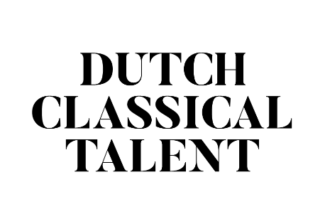
Declaration Dutch Classical Talent
for the Tour in 2023|2024

Dutch Classical Talent
Dutch Classical Talent is an 18 month long program for talented young classical musicians not older than 28 years (singers not older than 30 years) who study or have studied at a Dutch conservatory. Four winners follow a coaching program and play fifteen concerts in the most important Dutch concert halls.

Dutch Classical Talent is an initiative of the Dutch concert halls and the JCP Foundation.

Application dossier
The complete application dossier should consist of the following:
1. Application form including an audition program with motivation and biography.
2. One digital picture per musician/ensemble.
4. Letter of recommendation (signed) including an approval of the audition program.
5. Scan and signed version of this document.
Application form
You can apply as soloist or as an ensemble. By soloist we mean an instrumentalist who can perform a complete recital program without accompaniment. Vocalists can apply as soloist with accompaniment (age accompanist under 40) unless they present themselves clearly as a soloist through their program. A program with lied-repertoire is categorized under duo. With ensemble we mean a duo or a larger ensemble with a maximum of six members. Pick one contact person who fills out and signs the application form. Please fill out the digital form completely. Only complete filled out forms will be admitted.

Audition program
Apart from the recital program of approx. 80 minutes you should hand in two selections for the two auditions (taken from the recital program), one of 15 and one of 20 minutes. The audition selection will be approved by the jury and if necessary altered. In the week prior to the audition the jury will announce the final audition program. The audition program should meet the following requirements:

- The program is suitable for a recital of approx. 80 minutes (excluding break).
- The program is daring and varied
- The program has an exact length of each composition and all separate parts or movements.
- The program contains a short motivation of approx. 100 words.

The second round will, next to the audition program of 20 minutes, contain a short interview by the jury.

Deadlines
Application is possible until no later than Friday 30 September 2022.
- The application is not complete without all scans and pictures.
- You will receive a confirmation after we have received the complete application.
- Let us know if you haven’t received the confirmation within 5 working days.

Schedule
Monday 24 October 2022 First round auditions at TivoliVredenburg
Tuesday 25 October 2022 First round auditions at TivoliVredenburg
Monday 14 November 2022 Second round auditions (8 candidates/ensembles) at TivoliVredenburg

Should you, after the two audition rounds, be chosen as one of the four finalists, you can expect the following:

Dec 2022 Kick off Dutch Classical Talent including a photo session with Marco Borggreve in Utrecht. (Keep one day free, bring make-up, concert and casual clothes, your agenda and a repertoire list!) Date will be announced later.
Dec 2022/Jan 2023 Start coaching program; talks and orientation program
spring 2023 Work out study outline with masterclasses etc.
Sept 2023 Opening Dutch Classical Talent season. Sneak preview
during a lunch concert on a Friday at TivoliVredenburg.
2023/2024 Tour with approx. fifteen concerts at big concert halls in The Netherlands, media attention, please keep four weeks free.

Contact
Cécile Gouder de Beauregard
Coördinator Dutch Classical Talent

info@dutchclassicaltalent.nl
www.dutchclassicaltalent.nl

Declaration
Undersigned wishes to participate in Dutch Classical Talent 2023|2024 and agrees with the audition regulations found on the website.

date
name
signature

